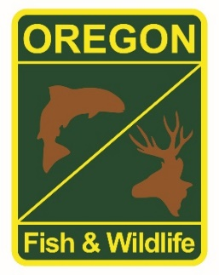

**State Fisheries Genetics Lab Tissue Sample Intake Form**

Please complete the top part of this form and send to: [kathleen.omalley@oregonstate.edu](mailto:kathleen.omalley@oregonstate.edu)

Make arrangements with us prior to dropping off the tissue samples and include a copy of this form with your samples.

**Project dropping off samples: Lower Rogue Seining Project**

**Person dropping off samples:**

**Phone: Steven Mazur Email:** [Steve.J.Mazur@state.or.us](mailto:Steve.J.Mazur@state.or.us)

**Description of samples (e.g. species, collection locations, collection dates, collection methods, number of samples, life stage; may attach spreadsheet): See spreadsheet**

**Species: Steelhead**

**Life Stage: Rogue River Half Pounders (250-410 mm Fork Length)**

**Location: Huntley Park, Rogue River (River Mile 8)**

**Method: Batch samples up to 50 samples per collection day of caudle fin clips from individual fish**

**Collection dates (all 2019): 8/14, 8/16, 8/19, 8/21, 8/23, 8/25, 8/28, 8/30, 9/3, 9/6 9/9, 9/11, 9/13, 9/16, 9/18, 9/20, 9/23, 9/25 approximately**

**Number of Samples: Up to 50 samples per batch, approximately 334 total samples**

**If applicable, known origin (e.g. natural or hatchery): Natural**

**Sample type (e.g. fin tissue, scale, muscle, etc): Fin Tissue**

**Storage method (e.g. dry, 95% ethanol, RNA later, etc): 95% Ethanol batch samples**